Nam Nguyen

npn190000

Exercises

**Section 8.1: 1(b), 2, 9, 10, 19, 20**

1. Using naive Gaussian elimination, factor the following matrices in the form A = LU, where L is a unit lower triangular matrix and U is an upper triangular matrix.

Answer:

2. Consider the matrix

a. Determine a unit lower triangular matrix M and an upper triangular matrix U such that MA = U.

b. Determine a unit lower triangular matrix L and an upper triangular matrix U such that A = LU. Show that M L = I so that L = M−1 .

Answer:

9. Consider

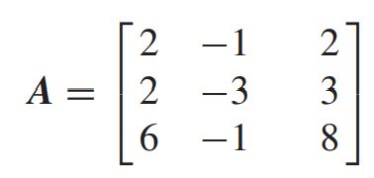

a. Find the matrix factorization A = **LDU’** , where L is unit lower triangular, D is diagonal, and U’ is unit upper triangular.

b. Use this decomposition of A to solve Ax = b, where b = [−2, −5, 0]T .

Answer:

10. Repeat the preceding problem for

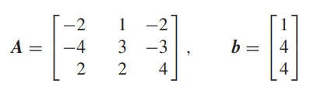

Answer:

19. a. Prove that the product of two lower triangular matrices is lower triangular.

b. Prove that the product of two unit lower triangular matrices is unit lower triangular.

c. Prove that the inverse of a unit lower triangular matrix is unit lower triangular.

d. By using the transpose operation, prove that all of the preceding results are true for upper triangular matrices.

Answer:

20. Let L be lower triangular, U be upper triangular, and D be diagonal.

a. If **L** and **U** are both unit triangular and **LDU** is diagonal, does it follow that L and U are diagonal?

b. If **LDU** is nonsingular and diagonal, does it follow that L and U are diagonal?

c. If L and U are both unit triangular and if **LDU** is diagonal, does it follow that **L = U = I**?

Answer:

**Section 8.2: 4, 7, 8, 11(a,c)**

4. (Multiple choice) From a vector norm, we can create a subordinate matrix norm. Which relation is satisfied by every subordinate matrix norm?

a. ||Ax|| ||A|| ||x||

b. ||I|| = 1

c. ||AB|| ||A|| ||B||

d. ||A+ B|| ||A||+||B||

e. None of these.

Answer:

7. (Multiple choice) A sufficient condition for the Jacobi method to converge for the linear system Ax = b.

a. A − I is diagonally dominant.

b. A is diagonally dominant.

c. G is nonsingular.

d. The spectral radius of G is less than 1.

e. None of these

Answer:

8. (Multiple choice)

A sufficient condition for the Gauss-Seidel method to work on the linear system **Ax = b**.

a. A is diagonally dominant.

b. A − I is diagonally dominant.

c. The spectral radius of A is less than 1.

d. G is nonsingular.

e. None of these

Answer:

11. Determine the condition numbers κ(A) of these matrices:

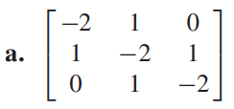

Answer:

**Section 8.3: 8, 9, 10, 11, 12, 13, 14, 15**

8. (Multiple choice) Let A be an n ×n invertible (nonsingular) matrix. Let x be a nonzero vector. Suppose that **Ax = λx**. Which equation does not follow from these hypotheses?

a. Ak x = λk x

b. λ−k x = (A−1)k x for k ≥0

c. p(A)x = p(λ)x for any polynomial p

d. Ak x = (1 − λ)k x

e. None of these.

Answer:

9. (Multiple choice) For what values of s will the matrix I − svv∗ be unitary, where v is a column vector of unit length?

a. 0, 1

b. 0, 2

c. 1, 2

d. 0, √2

e. None of these.

Answer:

10. (Multiple choice) Let **U and V** be unitary n × n matrices, possibly complex. Which conclusion is not justified?

a. U + V is unitary.

b. U∗ is unitary.

c. UV is unitary.

d. U −vv∗ is unitary when ||v|| = √2 and v is a column vector.

e. None of these.

Answer:

11. (Multiple choice) Which assertion is true?

a. Every n × n matrix has n distinct (different) eigenvalues.

b. The eigenvalues of a real matrix are real.

c. If U is a unitary matrix, then U∗ = UT

d. A square matrix and its transpose have the same eigenvalues.

e. None of these.

Answer:

12. (Multiple choice) Consider the symmetric matrix

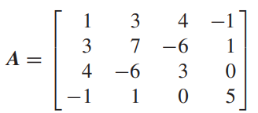

What is the smallest interval derived from Gershgorin’s Theorem such that all eigenvalues of the matrix A lie in that interval?

a. [−7, 9]

b. [−7, 13]

c. [3, 7]

d. [−3, 17]

e. None of these.

Answer:

13. (True or false) Gershgorin’s Theorem asserts that every eigenvalue λ of an n ×n matrix A must satisfy one of these inequalities:

Answer:

14. (True or false) A consequence of Schur’s Theorem is that every square matrix A can be factored as A = PTP−1 , where P is a nonsingular matrix and T is upper triangular.

Answer:

15. (True or false) A consequence of Schur’s Theorem is that every (real) symmetric matrix **A** can be factored in the form **A = PDP−1**, where **P** is unitary and **D** is diagonal.

Answer:

Computing Exercises

**Section 8.1: 4, 8**

4. Write and test a procedure for determining A−1 for a given square matrix A of order n. Your procedure should use procedures Gauss and Solve.

Answer:

8. Investigate the numerical difficulties in inverting the following matrix:

Answer:

<https://www.chegg.com/homework-help/questions-and-answers/investigate-numerical-difficulties-inverting-following-matrix-00001-5096-5101-1853-0-3737--q20738529>

**Section 8.2: 3, 4**

3. Using the Jacobi, Gauss-Seidel, and the SOR (ω = 1.4) iterative methods, write and run code to solve the following linear system to four decimal places of accuracy:

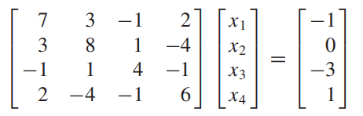

Compare the number of iterations in each case. Hint: Here, the exact solution is x = (−1, 1, −1, 1)T

Answer:

<https://www.chegg.com/homework-help/questions-and-answers/3-using-jacobi-gauss-seidel-sor-w-14-iterative-methods-write-run-code-solve-follow-ing-lin-q45394536>

<https://www.chegg.com/homework-help/questions-and-answers/a3-using-jacobi-gauss-seidel-sor-14-iterative-methods-write-run-code-solve-follow-ing-line-q27291058>

4. (Continuation) Solve the system using the SOR iterative method with values of ω = 1(0.1)2. Plot the number of iterations for convergence versus the values of ω. Which value of ω results in the fastest convergence?

Answer:

**Section 8.3: 1, 10, 12**

1. Use Matlab, Maple, Mathematica, or other computer programs available to you to compute the eigenvalues and eigenvectors of these matrices:

Answer:

<https://www.mathworks.com/help/matlab/ref/eig.html>

10. Using mathematical software such as Matlab, Maple, or Mathematica, compute the singular value decomposition of these matrices, and verify that each result satisfies the equation **A = UDVT** :

Create the diagonal matrix **D = UTAV** to check the results (always recommended). One can see the effects of roundoff errors in these calculations, for the off-diagonal elements in **D** are theoretically zero.

Answer:

<https://www.mathworks.com/help/matlab/ref/double.svd.html>

12. Find the singular value decomposition of these matrices:

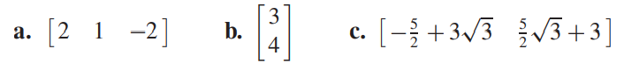

Answer:

https://www.mathworks.com/help/symbolic/singular-value-decomposition.html